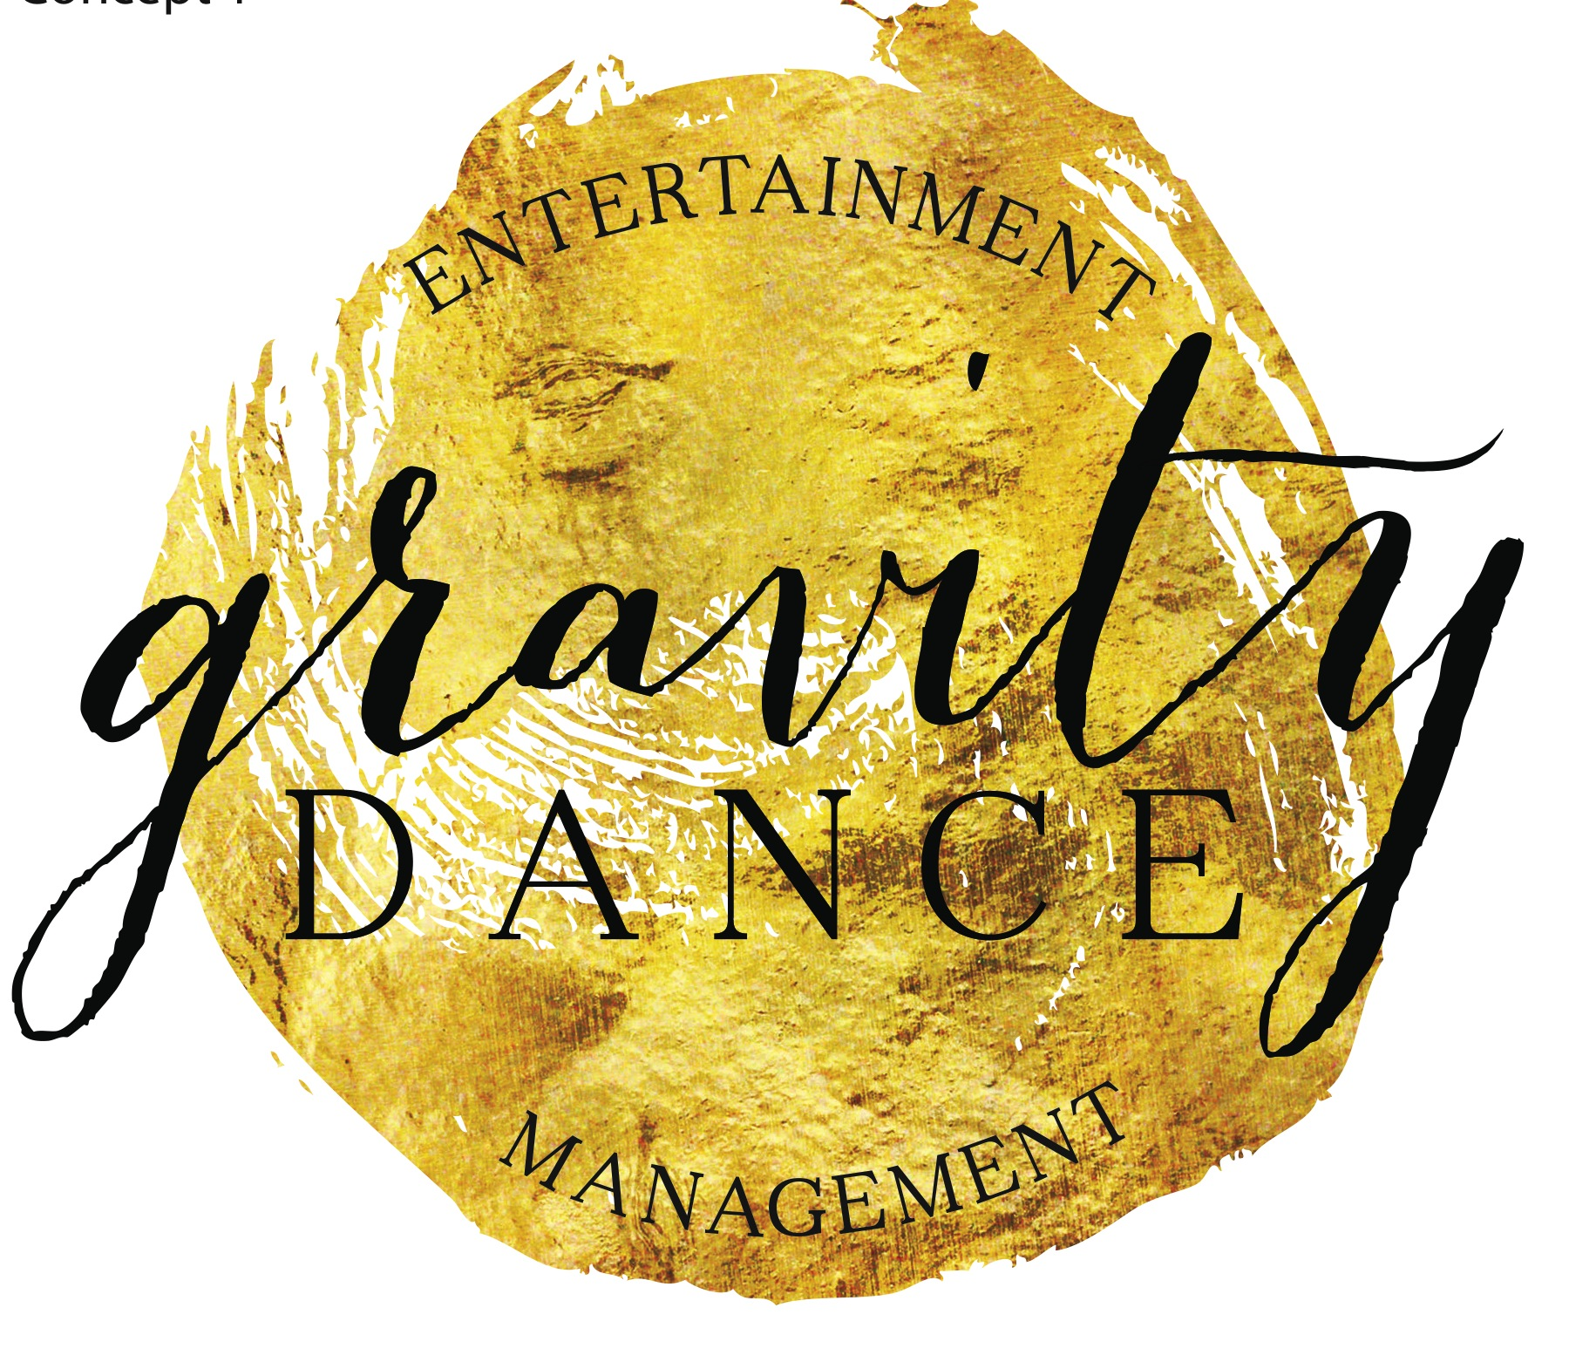

*EXCLUSIVE NEWS – GRAVITY ENTERTAINMENT MANAGEMENT (G.E.M) GRAVITY* ***TALENT AGENCY*** *OPENS DOORS!*

*We cannot be more excited to announce to you all that* ***Gravity Dance*** *will open the doors to an Exclusive Talent Agency in Term 2 2015.*

*The* ***Agency*** *will be by invitation only and will manage performers (aged 15+) in* ***all areas of the entertainment industry*** *assisting with further graduate studies, industry knowledge, professional master classes and giving them the tools, auditions and professional employment opportunities to obtain a career within the industry.*

*The Talent management service will work with performers on a professional level and along with business industry relationships will give performers employment opportunities and the one-on-one guidance to achieve a sustainable career in their chosen field.*

*We cannot be more excited to offer this service to* ***Gravity & Mitcham members*** *and up-skill our graduate students assisting them in experiencing the wonderful world of entertainment.*

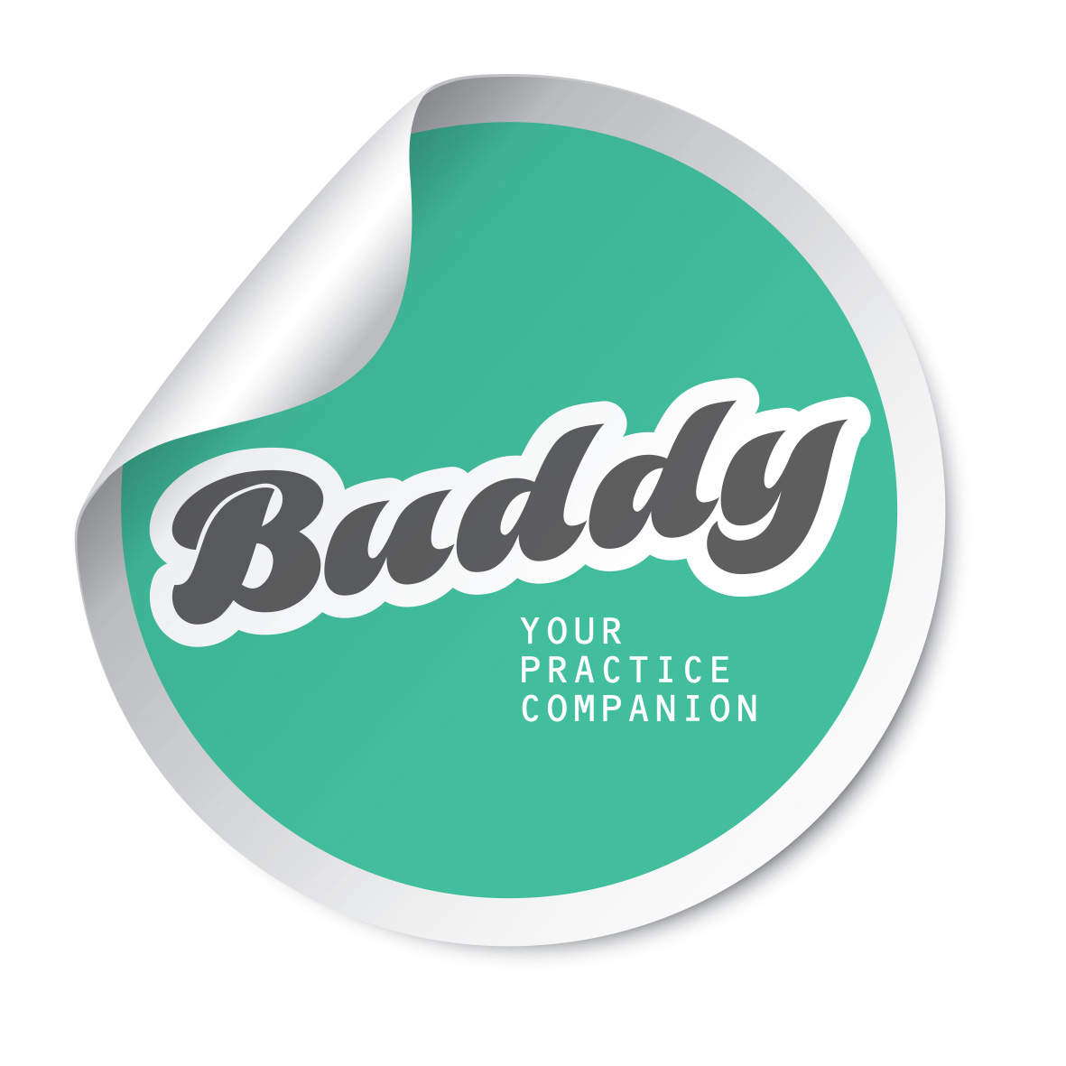*To register your interest please email* [*info@gravitydance.com.au*](mailto:info@gravitydance.com.au)

**BUDDY is hitting our doors this week!** Buddy is a unique practicing tool for our students, designed by our very own Miss Gabrielle.

It is an APP that the teachers will use to record the parts of class they want their students to practice. The content (video and notes), is uploaded on the spot to the safe and secure platform, called BUDDY. The students will log into the BUDDY website to access only their class and privately practice their classwork at home. **And unlike Youtube, BUDDY is a safe and secure way to access their classes.**

**W**e are trialling BUDDY during March and will be free to all Mitcham & Gravity Dance students. We know that this brand new innovation will create a huge difference to the way our students work. If you do not want to participate in this trial please let us know in the office immediately. 8352 2006



**WALK IN FOR A WORK OUT AND LEAVE FEELING LIKE YOU’VE HAD A MASSAGE!**

Gyrotonic is an organic and playful way of moving the body, taking you through all possible joint ranges of motion at various rhythms leaving you feeling fit, flexible and energised.

The techniques utilised in GYROTONIC® create stability where the body moves too much and mobility where the body doesn't move enough, enabling you to re-write old patterns of movement and move youthfully once again....and it's a lot of fun!

::Desktop:TAB - Pink Verticle.pdfWhether you are an elite athlete, a yoga enthusiast looking to add another dimension to your practice, or recovering from an injury, GYROTONIC® increases the enjoyment of living in our bodies. It increases flexibility, coordination and range of motion while at the same time toning and strengthening the body.

The main benefits include:

* Builds core strength, balance and agility
* Increased flexibility, coordination and stability
* Sculpts long muscles
* Compliments physical therapy and injury rehabilitation work
* Counteracts “computer back.” Improves posture and brings back suppleness in the spine. It lengthens the spine, taking pressure off of the lower back, opens up the chest and shoulders and alleviates neck tension.
* Decrease Stress. Focusing on your breath and rhythmic, flowing movements switches on the "de-stress" mechanisms in your body.
* Rejuvenates the body. Like many of our clients have said, it is the only exercise that makes you feel like you have had a full body massage.

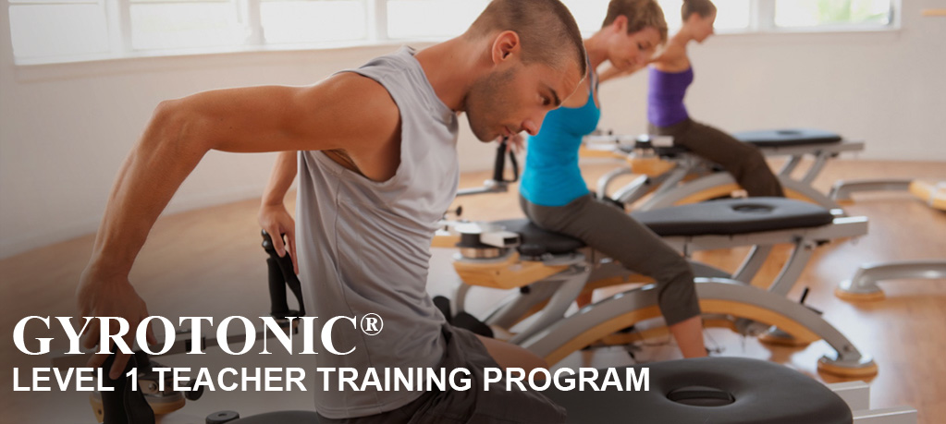

The Aligned Body 1a Park Street HYDE PARK call 83522006 / 0424241804